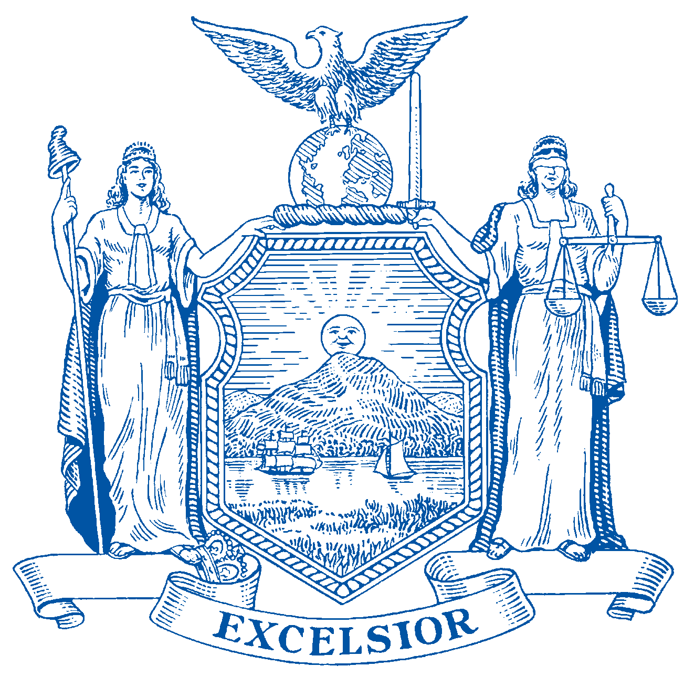
CHRIS BURDICK
Assemblymember 93rd District Westchester County
THE ASSEMBLY STATE OF NEW YORK ALBANY

CHAIR
Subcommittee on
Employment Opportunities for People with Disabilities

COMMITTEES
Correction Environmental Conservation
Housing People with Disabilities
Veterans’ Affairs
July 26, 2021

Ona Papageorgiou
NYSDEC
Division of Air Resources
625 Broadway
Albany, NY 12233-3250
Email: air.regs@dec.ny.gov

Dear Ms. Papageorgiou,

I write in support of the Clean Air Council’s technical comments (attached) on the proposed Department of Environmental Conservation regulations proposed for the oil and gas sector air emissions, 6 NYCRR Part 203.

As a member of the New York State Assembly standing committee on Environmental Conservation and a long-time advocate for the environment, both in my personal life and as an elected official, I recognize the necessity for all of us to be responsible stewards of the environment and that regulations protecting clean air are necessary, especially as we make regulations around oil and gas emissions.

The Clean Air Council is a nonprofit with highly regarded expertise in air emissions, technologies, and regulations nationwide. Their specific recommendations to the DEC details ways in which the rules can be strengthened with more current technologies and efficiencies that have been developed since 2018 to significantly cut greenhouse gas emissions and toxic air pollution from oil and gas facilities in New York.

The mounting and unprecedented extreme weather events including flooding, droughts, wildfires, heatwaves, and poor air quality days are alarming. We cannot ignore the massive amounts of greenhouse gas emissions and toxic pollutants unnecessarily released from oil and gas infrastructure in New York that are harming our health and the environment and are accelerating our climate emergency.

To reiterate, I support the Clean Air Council’s attached technical comments on the proposed DEC regulation for the oil and gas sector, 6NYCRR Part 203, and urge you to adopt them and incorporate them into your proposed regulations.

Sincerely,

Chris Burdick
Assemblymember, 93rd District

